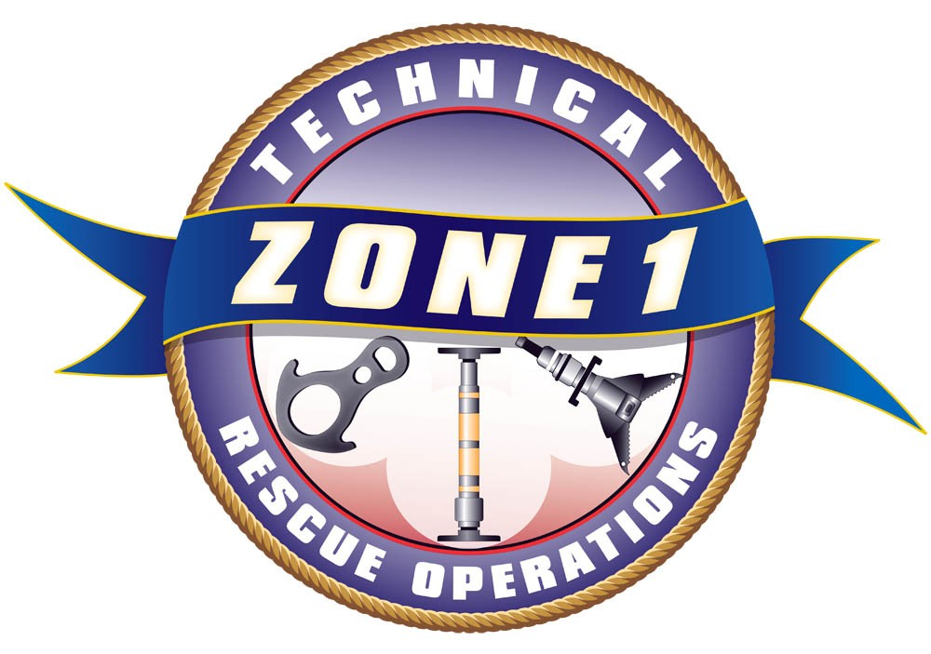
Zone 1 Technical Rescue
2015 Class Registration Form

Trench Rescue Technician Level - Initial |  |  |  |  |  |  | $600 each
Kirkland Fire St. 26 (9930 124th Ave. NE), Day 1  Days 2-5 will be at 132nd Ave. NE & NE 70th, Kirkland, WA. |  |  |  |  |  |  | June 15-19, 2015  0900-1800 hrs
Lunch is not provided.
PREREQUISITE:
Students must meet Trench Awareness Level (NFPA 1670) prior to first day of class or permission of Z-1 Instructional Staff. Information will be sent to you upon receipt of your registration.
Registration Information:
Please Print: (you may submit additional names on a separate sheet of paper)
Name: |  |  |  | Email:
Name: |  |  |  | Email:
Name: |  |  |  | Email:
Name: |  |  |  | Email:
Agency: |  |  |  | Phone:
Training Ofc: |  |  |  |  | Cancellation Deadline: May 25, 2015  No refunds after this date.  Tuition is payable upon registration  Minimum Class Size: 12  Maximum Class Size: 32  Priority will be given to Zone 1 registrants up to 60 days prior to first day of class.
T/Os Email:
Purchase Order:
Or attach check payable to: |  |  | Kirkland Fire Department
Please mail to: |  |  | Attn: Audrey Martin  123 5th Avenue  Kirkland, WA 98033
Billing Information:
Agency:
Address 1:
Address 2:
City, State, Zip:
Please fax registration to (425) 587-3651 or email to amartin@kirklandwa.gov
Questions? Please contact Larry Peabody @ (425) 587-3690 or lpeabody@kirklandwa.gov

