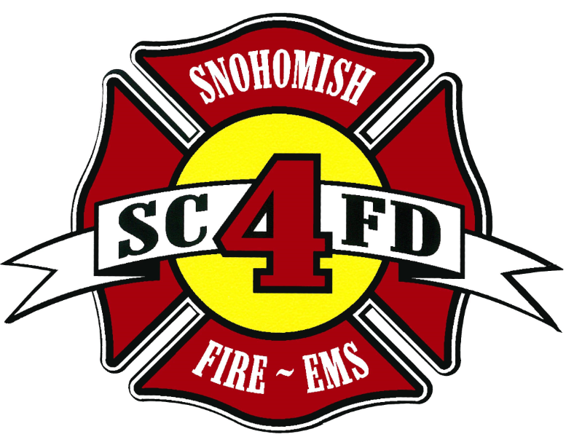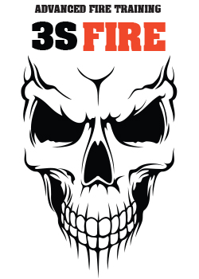
Snohomish County
Fire District #4
And
3S FIRE LLC.
PRESENT:

Rescue Systems 1
Four Day Course
CERTIFICATION: NFPA 1670, Operations Level for Structural Collapse Rescue
COURSE OVERVIEW: This is a 40-hour course based on Rescue Systems Washington curriculum that teaches foundational skills in heavy rescue. Skills include assessing, searching, breaching, shoring, extrication & safety for operations dealing with structural collapse.
ATTIRE/EQUIPMENT NEEDED: As this is primarily an outdoor class, attire appropriate to the weather will be needed. Expect to wear coveralls or work clothing, safety glasses, helmet or hard hat, work gloves, flashlight and/or head lighting and safety toed boots.
LEAD INSTRUCTORS: Rich Shrauner, Mike Juozapaitis, and John Tanaka, Brent Weir
Prerequisites: Must be sponsored by a Fire Service Agency and/or enrolled in a fire service educational program or course of study
Class Dates: June 23, 24, 25, and 26, 2015 minimum class size is 15 and max of 30

Class Time: 0800 – 1800 each day

Location: SCFD#4 Training Site @ 6425 South Machias Road, Snohomish, WA 98290
Cost: $650.00 per student- lunch, snacks, and beverages are provided each day
Cancellations: 3S Fire must be notified by email (10) working days prior to the scheduled start date of the class or the full student fee will be forfeit on a case by case basis. Substitutions are allowed.
Registrations: Register at 3sfire.net or for any questions call Juice @ (425) 231-8280
Lodging: Inn at Snohomish, 323 2nd St. Snohomish, WA 98290 ‪1-800-548-9993
Howard Johnson, 3105 Pine St. Everett, WA 98201 (425)-303-8284

