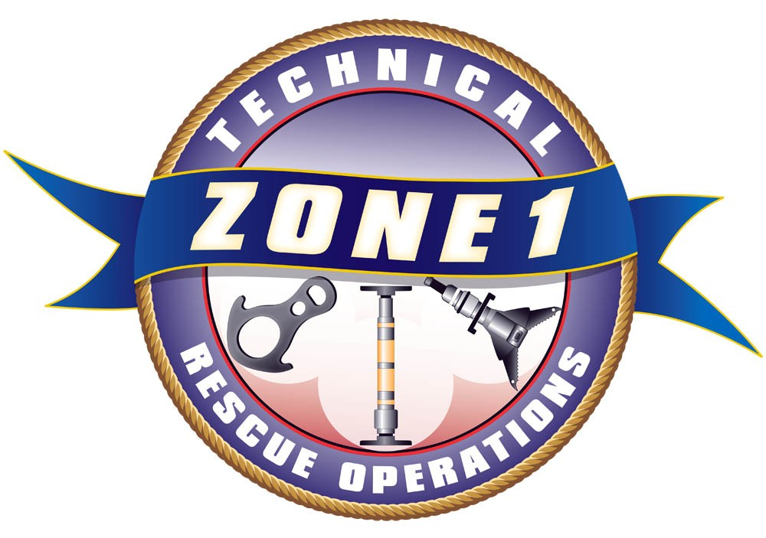
Zone 1 Technical Rescue
2015 Class Registration Form

Rope Rescue Technician Level – Initial |  |  |  |  |  |  | $600 each
Northshore Fire Training Center  7220 NE 181st St, Kenmore, WA |  |  |  |  |  |  | April 27-May 1, 2015  0830-1800 hrs  Lunch is not included
PREREQUISITE:
Students must meet Rope Ops Level (NFPA 1670) prior to first day of class or permission of Z-1 Instructional Staff. Information will be sent to you upon receipt of your registration.
Registration Information:
Please Print: (you may submit additional names on a separate sheet of paper)
Name: |  |  |  | Email:
Name: |  |  |  | Email:
Name: |  |  |  | Email:
Name: |  |  |  | Email:
Agency: |  |  |  | Phone:
Training Ofc: |  |  |  |  | Cancellation Deadline: April 6, 2015  No refunds after this date.  Tuition is payable upon registration  Minimum Class Size: 16  Maximum Class Size: 32  Priority will be given to Zone 1 registrants up to 60 days prior to first day of class.
T/Os Email:
Purchase Order:
Or attach check payable to: |  |  | Kirkland Fire Department
Please mail to: |  |  | Attn: Audrey Martin  123 5th Avenue  Kirkland, WA 98033
Billing Information:
Agency:
Address 1:
Address 2:
City, State, Zip:
Please fax registration to (425) 587-3651 or email to amartin@kirklandwa.gov
Questions? Please contact Larry Peabody @ (425) 587-3690 or lpeabody@kirklandwa.gov

