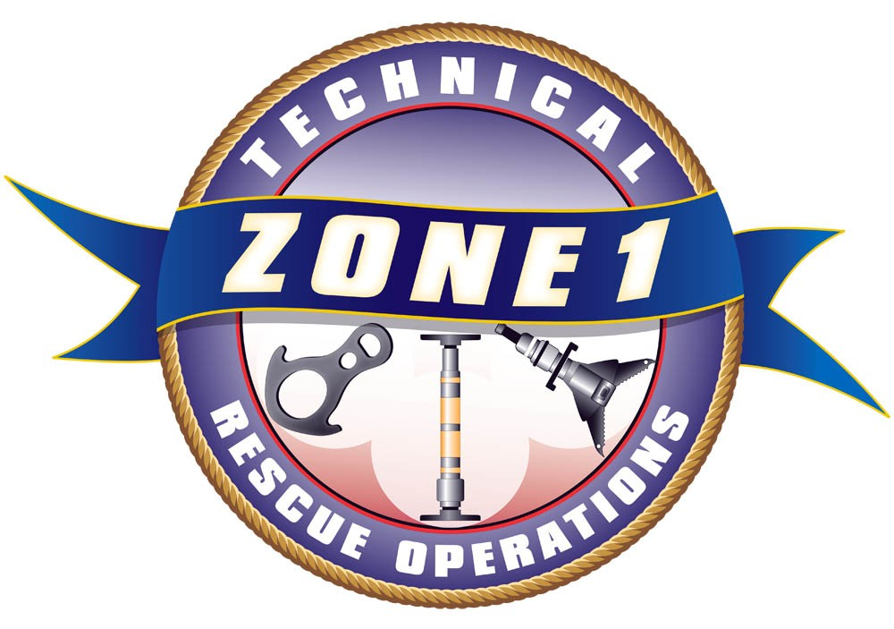
Zone 1 Technical Rescue
2015 Class Registration Form

Confined Space Rescue Technician Level – Initial |  |  |  |  |  |  | $500 each
May 12-14 @ Fire Training Academy @ North Bend  May 15 @ Kirkland Fire St. 26 – 9930 124th Ave. NE |  |  |  |  |  |  | May 12-15, 2015  0900-1800 hrs
Lunch will be provided at North Bend on May 12th – 14th. Please bring your own lunch on May 15th.
PREREQUISITE:
Students must meet Rope Ops Level (NFPA 1670) prior to first day of class or permission of Z-1 Instructional Staff. Information will be sent to you upon receipt of your registration. The CMC Confined Space Entry and Rescue, Revised 2nd Ed., manual is required and supplied by the student.
Registration Information:
Please Print: (you may submit additional names on a separate sheet of paper)
Name: |  |  |  | Email:
Name: |  |  |  | Email:
Name: |  |  |  | Email:
Name: |  |  |  | Email:
Agency: |  |  |  | Phone:
Training Ofc: |  |  |  |  | Cancellation Deadline: April 14, 2015  No refunds after this date.  Tuition is payable upon registration  Minimum Class Size: 12  Maximum Class Size: 32  Priority will be given to Zone 1 registrants up to 60 days prior to first day of class.
T/Os Email:
Purchase Order:
Or attach check payable to: |  |  | Kirkland Fire Department
Please mail to: |  |  | Attn: Audrey Martin  123 5th Avenue  Kirkland, WA 98033
Billing Information:
Agency:
Address 1:
Address 2:
City, State, Zip:
Please fax registration to (425) 587-3651 or email to amartin@kirklandwa.gov
Questions? Please contact Larry Peabody @ (425) 587-3690 or lpeabody@kirklandwa.gov

